COURIER MANAGEMENT SYSTEM



K.M.G COLLEGE OF ARTS & SCIENCE
DEPARTMENT OF COMPUTER APPLICATIONS

A project Report

Submitted By

AMBUJA D - (31523U18006)
DIVYADHRASHINI B - (31523U18022)
DIVYA R - (31523U18023) MEERAJASMIN V - (31523U18053)
AKSHAYA J - (31523U18005)

Project Development Phase:

Milestone 1 | Salesforce Account
Milestone 2 | Object
Milestone 3 | Tabs
Milestone 4 | Fields & Relationships
Milestone 5 | Validation Rules
Milestone 6 | Page Layouts
Milestone 7 | Flows
Milestone 8 | The Lightning App
Milestone 9 | Profile
Milestone 10 | Role
Milestone 11 | User
Milestone 12 | Reports & Dashboards

Product Backlog, Sprint Schedule, and Estimation:

Sprint | Functional Requirement (Epic) | User Story Numbe r | User Story / Task | Story Point s | Priority | Team Member s
Sprint-1 | Developer Setup | USN-1 | As a system administrator, I want to create and configure a Salesforce developer account so that I can set up and deploy the Courier Management System. | 3 | High | Bhadrinath D
Sprint-2 | Data Modeling | USN-2 | As an admin, I want to create Customer, Shipment, Delivery | 5 | High | Chandru S

Sprint | Functional  Requirement (Epic) | User  Story Number | User Story / Task | Story Points | Prio rity | Team  Member s
Agent, Branch, and Invoice objects with proper relationships so that
courier data is stored and managed efficiently.
Sprint-2 | Data Modeling | USN-3 | As a staff member, I want tabs and a Lightning App for all courier modules so that I can easily  navigate and perform daily operations. | 5 | High | Dhanachezch iyan E
Sprint-3 | Automation | USN-4 | As a system, I want to validate shipment details such as delivery dates, addresses, and mandatory fields so that incorrect or  incomplete records are prevented. | 3 | High | Jagadeeswar an D
Sprint-3 | Automation | USN-5 | As a dispatcher, I want automated flows for shipment status updates and agent assignment so that  deliveries are processed faster without manual intervention. | 3 | High | Bhadrinath D
Sprint-4 | Security | USN-6 | As an administrator, I want role-based access control for  managers, agents, and staff so that sensitive shipment and billing data is secure. | 5 | High | Chandru S
Sprint-5 | Reports | USN-7 | As a branch manager, I want reports showing delivery performance, shipment status, and revenue so that I can monitor  operations and make informed decisions. | 4 | High | Dhanachezch iyan E
Sprint-6 | Dashboards | USN-8 | As a branch manager, I want dashboards showing delivery performance, shipment status, and revenue so that I can monitor operations and make informed decisions. | 4 | Medi um | Jagadeeswar an D

Project Tracker, Velocity & Burndown Chart:

Sprint | Total Story Points | Durati o n | Sprint Start Date | Sprint End Date (Planned) | Story Points Completed (as on Planned End Date) | Sprint Release Date (Actual)
Sprint-1 | 20 | 6 Days | 24 March 2026 | 29 March 2026 | 20 | 29 Oct 2022

Sprint | Total Story Points | Durati o n | Sprint Start Date | Sprint End Date (Planned) | Story Points Completed (as on Planned End  Date) | Sprint Release Date (Actual)
Sprint-2 | 20 | 6 Days | 31 March 2026 | 05 March 2026
Sprint-3 | 20 | 6 Days | 07 March 2026 | 12 March 2026
Sprint-4 | 20 | 6 Days | 14 March 2026 | 19 March 2026

INTRODUCTION
- Courier and logistics companies face challenges in efficiently managing shipments and deliveries due to manual operations and disconnected systems. These issues lead to delayed updates, poor customer visibility, and operational inefficiencies.
- The Courier Management System (CMS) is a Salesforce-based cloud solution that centralizes shipment booking, tracking, delivery agent assignment, automated status updates, billing, and analytics. The system improves operational efficiency, enhances customer satisfaction, and provides real-time business insights.

Milestone 1: Salesforce Account Creation
  - Successfully created account in salesforce developer edition

Here is the screenshot of my developer account creation:
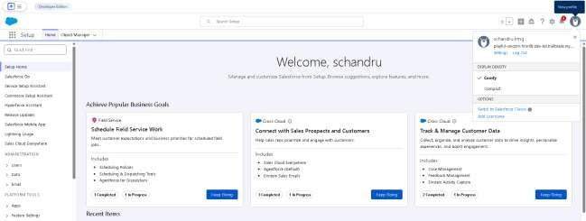

Milestone 2- Object:

Steps to Implement :

Activity 1: Create Customer Object
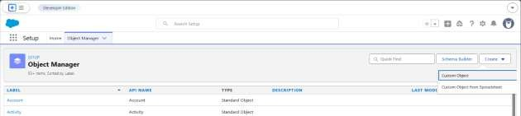

Creating new custom object named

- customer:
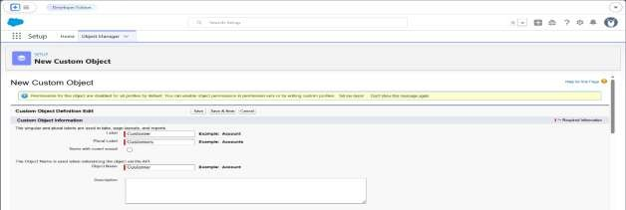

- shipment:
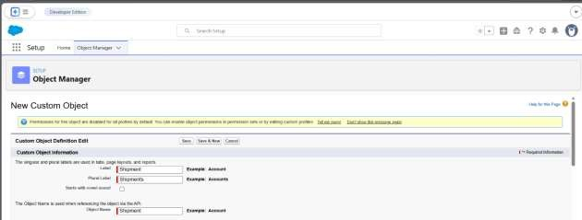
Successfully created shipment object
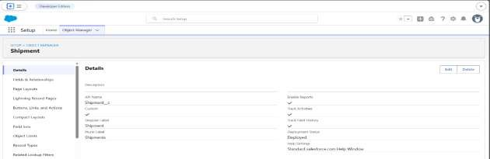

Milestone 3 – Tabs
Activity 1: Creating a Tab for Customer Object
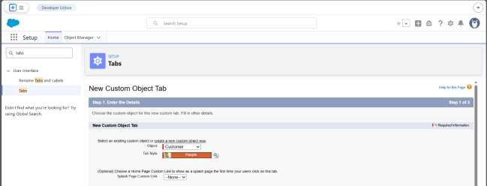

Created all six tabs:

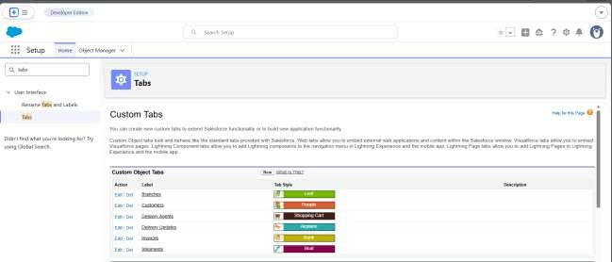

Milestone 4: Fields & Relationships

Activity 1: Creation of fields for the Customer Object

- Email
- Phone
- Address
- Customer type
- City
- State
- Pincode
- Is active
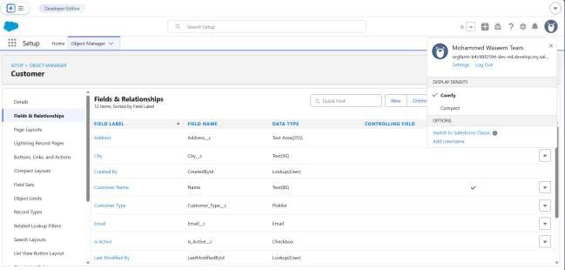

Activity 2: Creation of fields for the Shipment Object
  - Source address
  - Destination address
  - Weight
  - Price
  - Status
  - Expected date
  - Shipment type

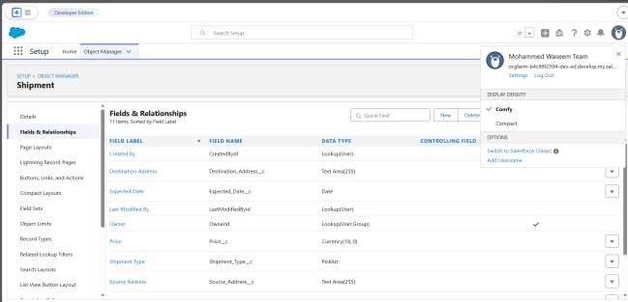

Activity 3: Creation of fields for Delivery_Agent Object
    - Email
    - Phone
    - Status
    - Joining date

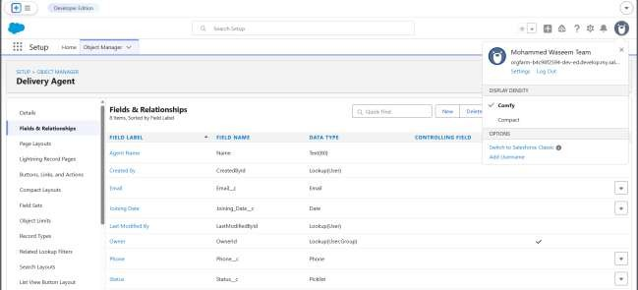

Activity 4: Creation of fields for Branch Object
  - Branch name
  - Branch code
  - City
  - State
  - Manager name

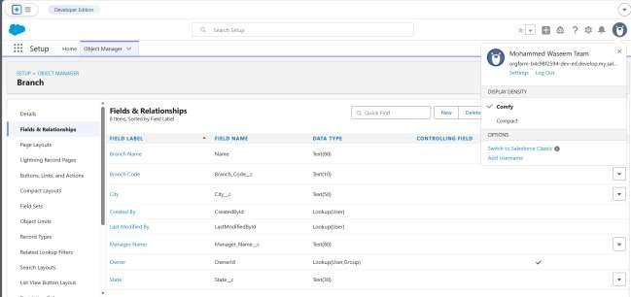

Activity 5: Creation of fields for Delivery_Update Object

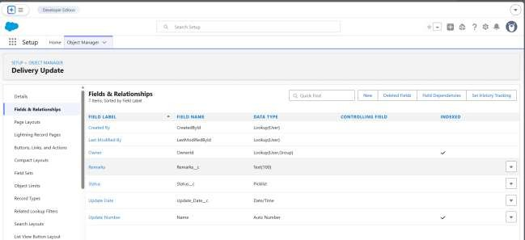

Activity 6: Creation of fields for Invoice Object
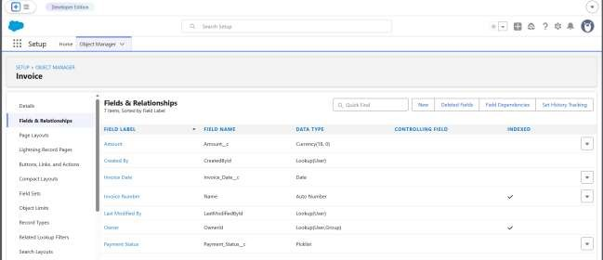

Milestone 5-Validation Rules :

Activity 1: Creating Validation Rules on Customer c
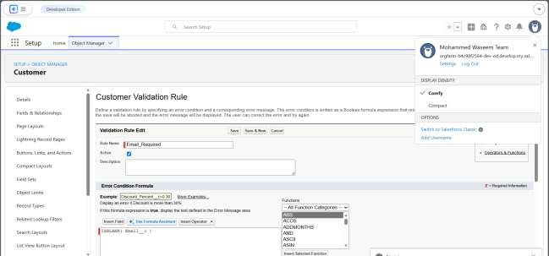

Activity 2: Creating Validation Rules on Shipment c
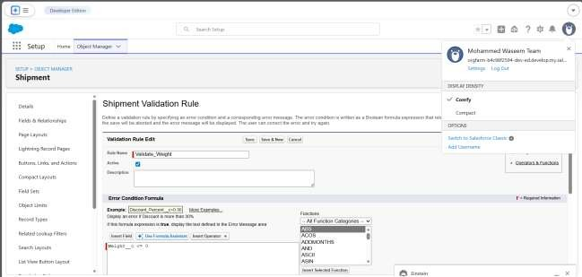

Activity 3: Creating Validation Rules on Delivery_Agent c
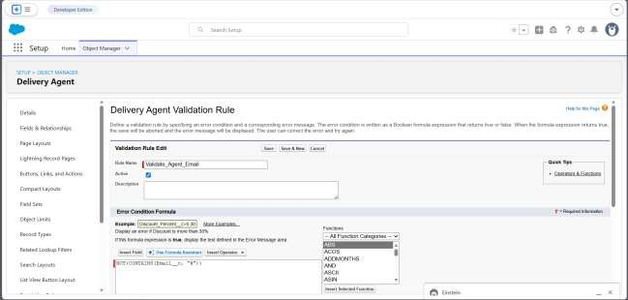

Activity 4: Creating Validation Rules on Branch c

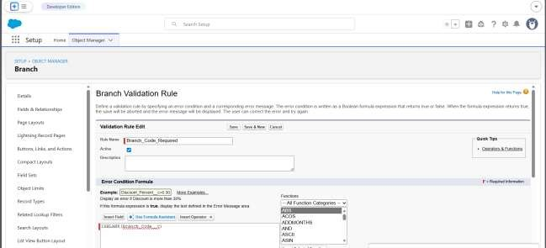

Activity 5: Creating Validation Rules on Delivery_Update c

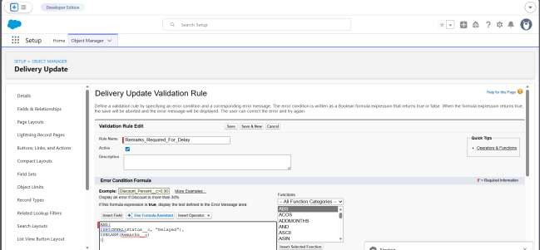

Milestone 6 - Page Layouts :
Activity 1: Editing Page Layout for Customer c
Section 1: Customer Information Section 2: Address Details
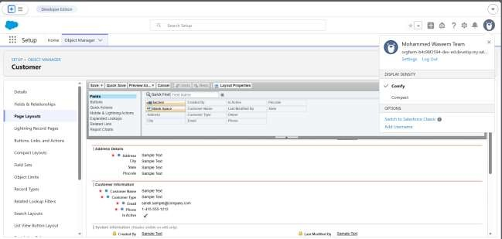

Activity 2: Editing Page Layout for Shipment c

Section 1: Shipment Details Section 2: Address Information Section 3: Delivery Information
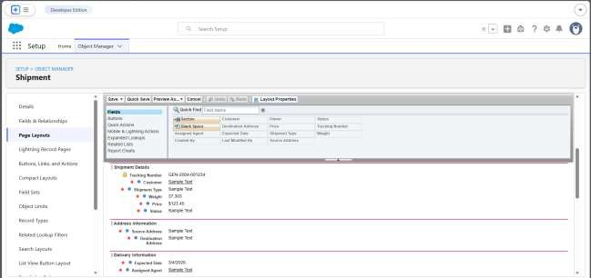

Activity 3: Edit Page Layout for Delivery_Agent c

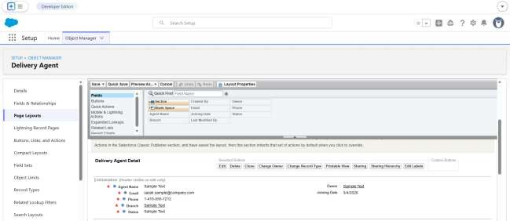

Activity 4: Edit Page Layout for Branch c

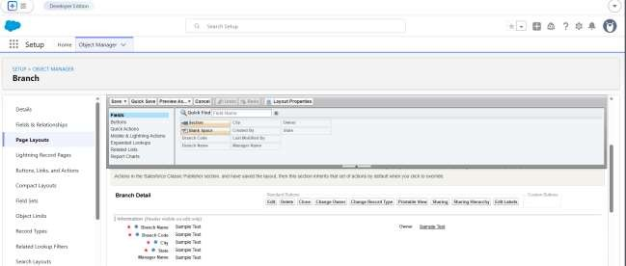

Activity 5: Edit Page Layout for Delivery_Update c
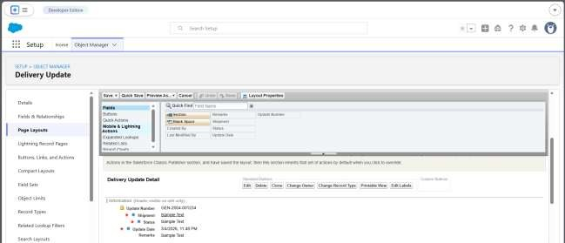

Activity 6: Edit Page Layout for Invoice c

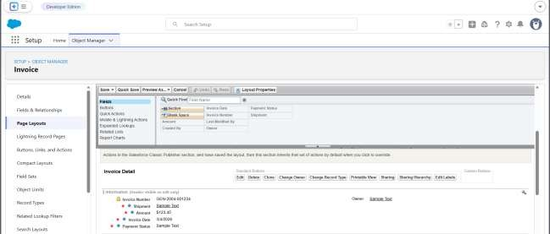

Milestone 7 – Flows

Created and activated the Record-Triggered Flow

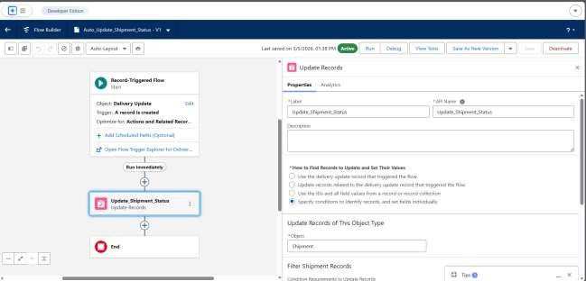

Milestone 8 - The Lightning App :
Activity 1: Creating a Lightning App
Creating the Courier Management System App

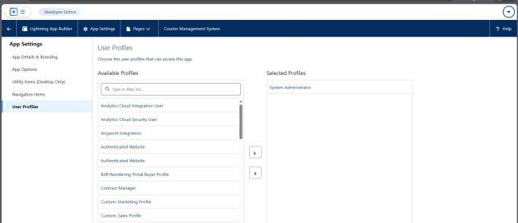

Milestone 9- Profile:

Activity 1: Creating a Custom Profile – Courier Admin
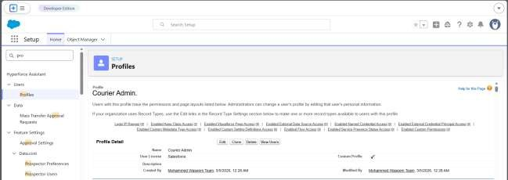

Activity 2: Created a Custom Profile – Branch Manager

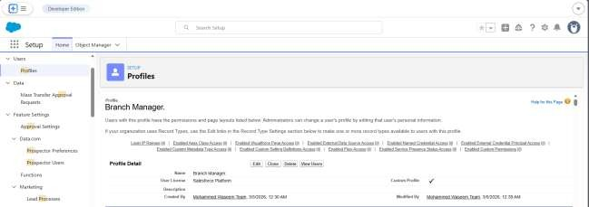

Activity 3: Created a Custom Profile – Delivery Agent

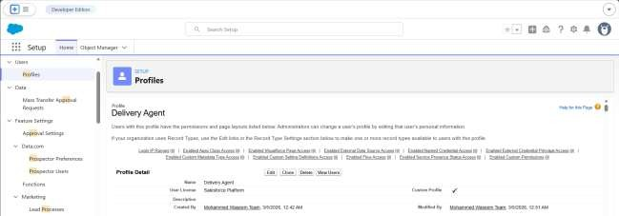

Activity 4: Created a Custom Profile – Customer Support

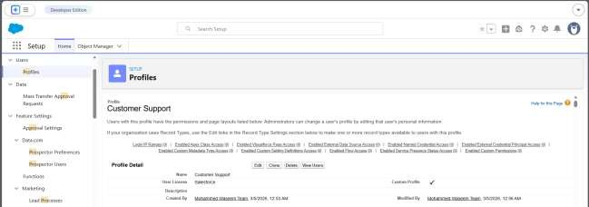

Milestone 10- Role:

Activity 1: Creation of Courier Admin Role

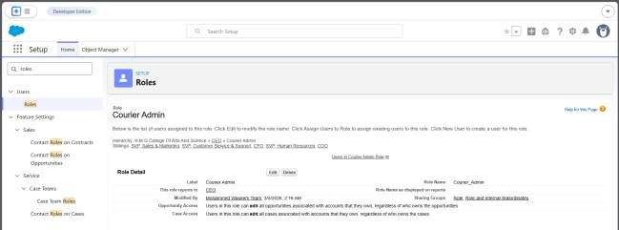

Activity 2: Creating Branch Manager Role Under Courier Admin Role

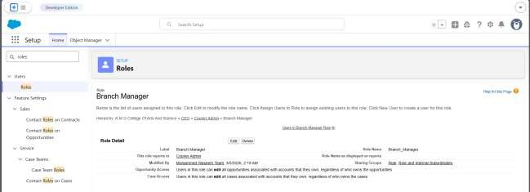

Activity 3: Creating Delivery Agent Role Under Branch Manager Role

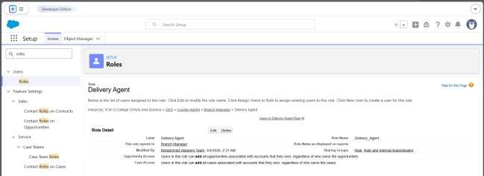

Activity 4: Creating Customer Support Role Under Branch Manager

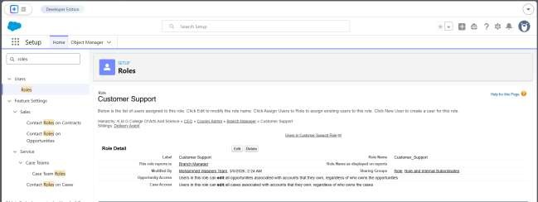

Milestone 11- User :

Activity 1: To Create a User
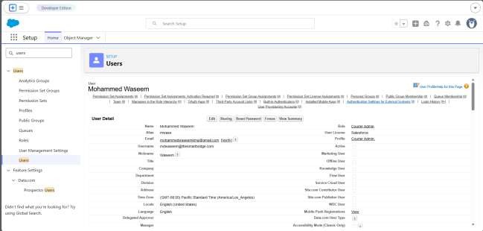

Activity 2: Creating Other Users

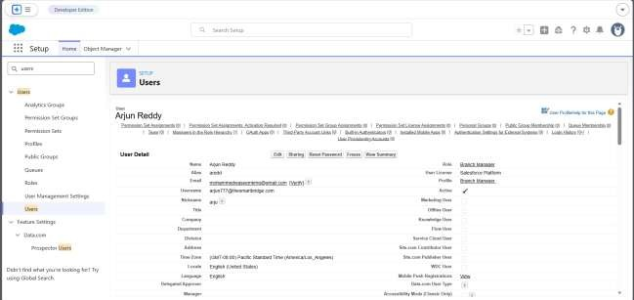

Milestone 12 : Reports & Dashboards
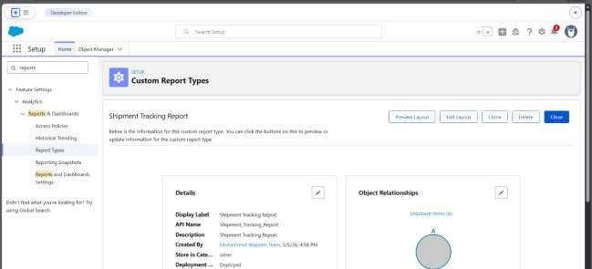
Activity 1: Create Report Types Created Shipment Report Type

Created Customer Report Type

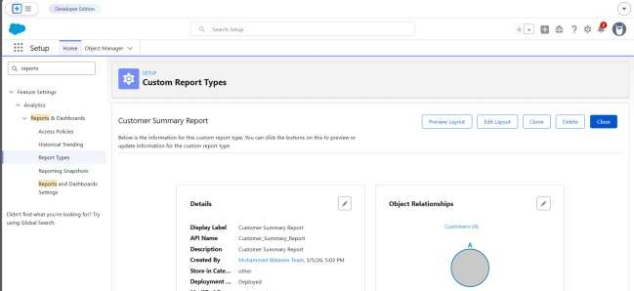

Created Agent Performance Report Type

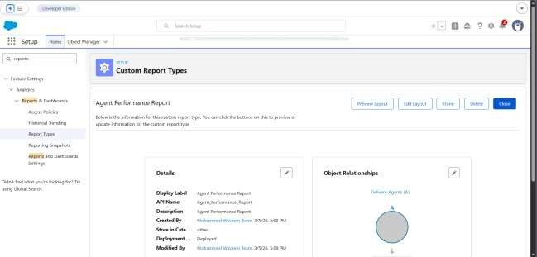

Activity 2: Create Reports
Report 1: Shipment Status Summary Report

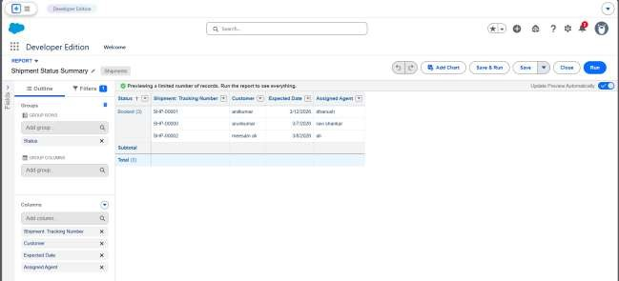

FUNCTIONAL & PERFORMANCE TESTING

Dashboard & Visualization

It is more easy to understand and maintain courier details for customers to maintain their various shipments , performance reports and revenue by branch reports and more.
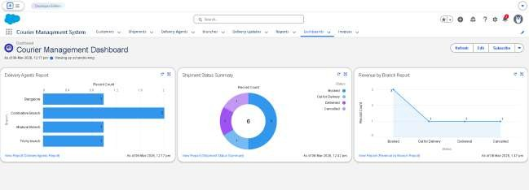

Flow Automation
- Here you can automate the tasks using flow automation
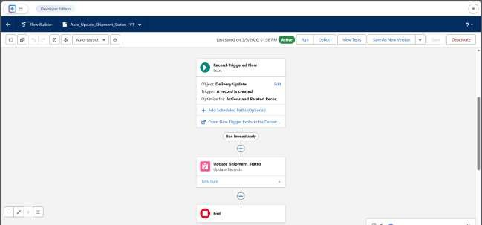

delivery status updates

- The shipment and delivery status can be viewed in this given screenshot

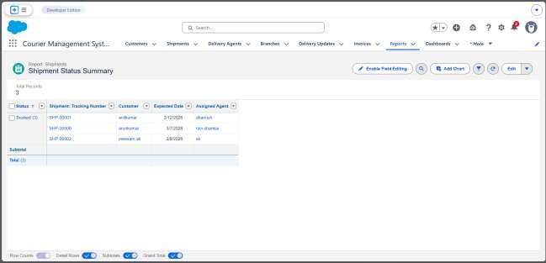

Invoice generation

- While creation of customer and shipments Its helpful to create a Invoice Record which helps to see the shipment details , amount , Invoice date etc.
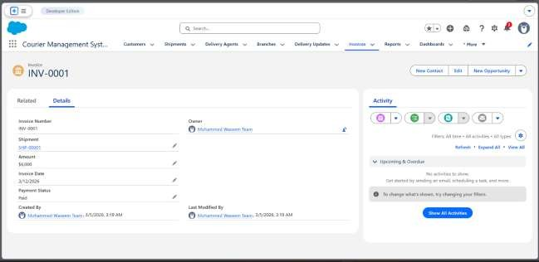

Conclusion:
- The Courier Management System (CMS) developed using the Salesforce platform successfully demonstrates how cloud technology can be used to manage courier operations efficiently. The system helps in organizing customer details, shipment information, delivery agents, branches, invoices, and delivery updates in a centralized environment.
- Through this project, various Salesforce features such as custom objects, fields, relationships, validation rules, page layouts, flows, reports, dashboards,
profiles, roles, and users were implemented. These components help in
maintaining accurate records, automating shipment processes, and improving operational efficiency.
- The system also provides better visibility of shipment status, delivery performance, and revenue reports through dashboards and reports. This helps managers and staff monitor courier operations and make better decisions.
- Overall, the Courier Management System reduces manual work, improves data accuracy, and ensures smooth management of courier services. The project
demonstrates how Salesforce can be effectively used to build scalable and efficient business applications.

